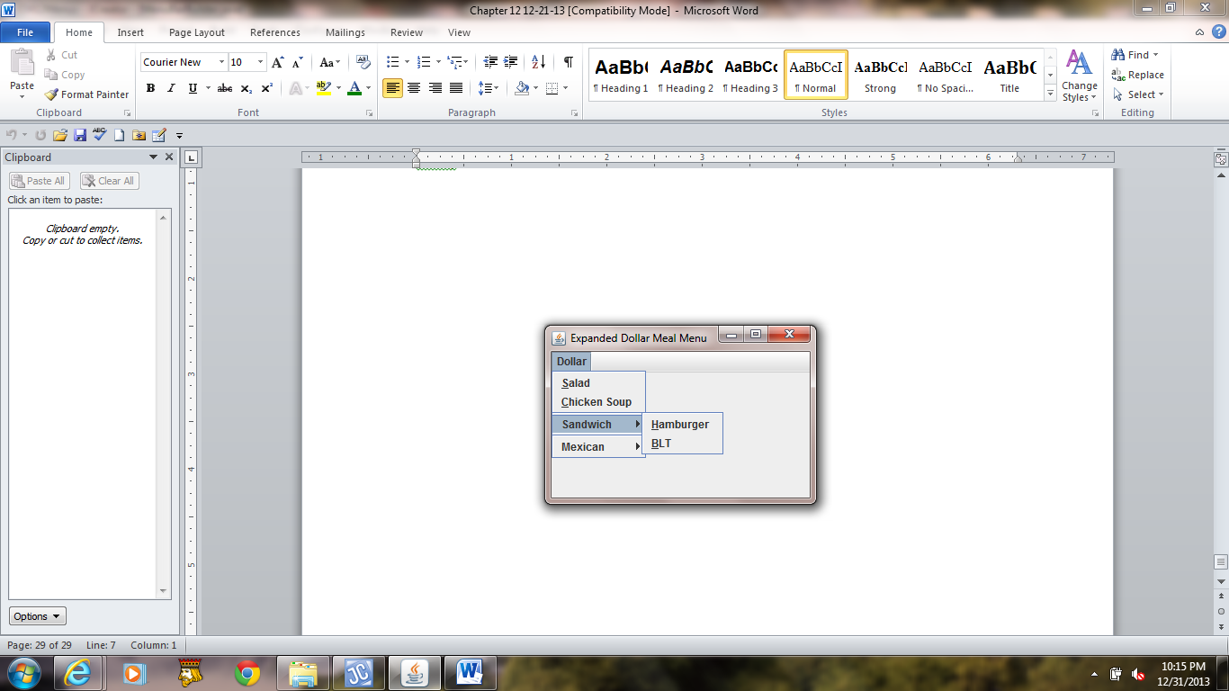 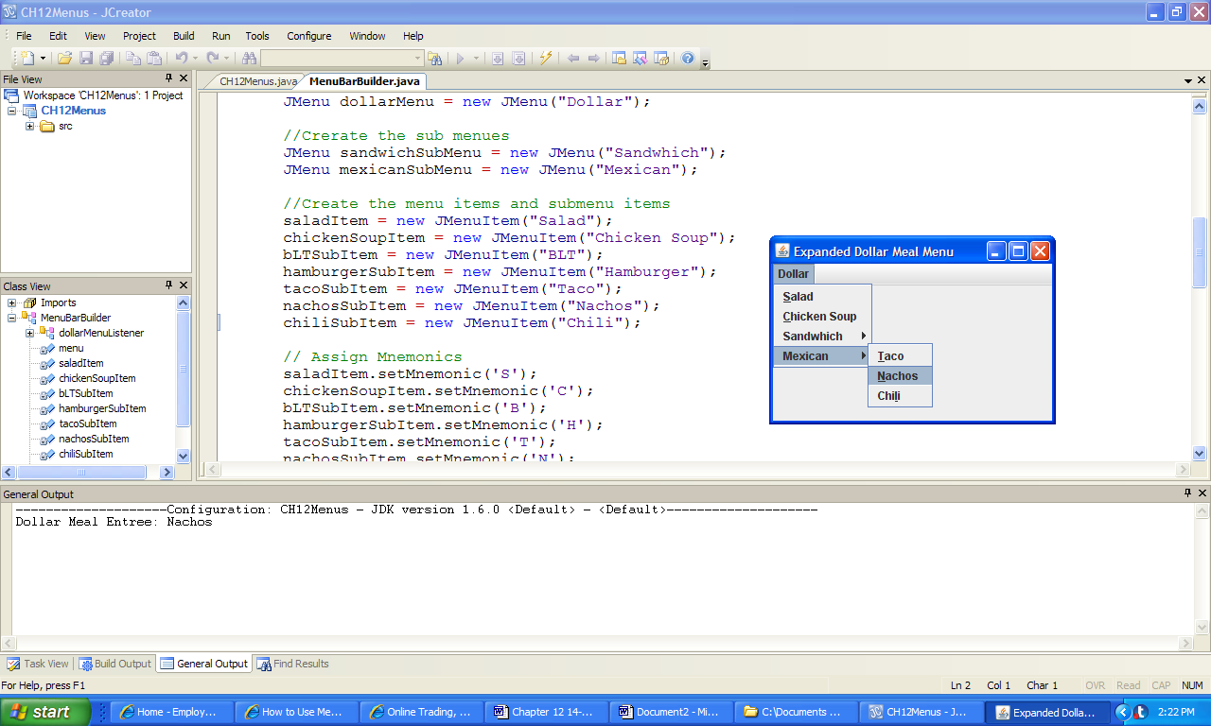

**a) b)**

*Console Output:*

Dollar Meal Entree: Nachos

**Figure 12.15 The GUI menu and output produced by the application Menus.**